# Target Journal

*American Journal of Human Genetics*

Other ideas: *PLoS Genetics*, *Genetic Epidemiology*

# Title

Adjusting for too many principal components can induce spurious associations in genome- wide association studies in admixed populations

# Authors and Affiliations

Kelsey E. Grinde,1* Alexander P. Reiner,2*,*3 Brian L. Browning,4 Timothy A. Thornton,5*,*6 Sharon R. Browning6 (pending confirmation)

1. Department of Mathematics, Statistics, and Computer Science, Macalester College, Saint Paul, MN, 55105, USA
2. Public Health Sciences Division, Fred Hutchinson Cancer Research Center, Seattle, WA, 98109, USA
3. Department of Epidemiology, University of Washington, Seattle, WA, 98195, USA
4. Division of Medical Genetics, Department of Medicine, University of Washington, Seat- tle, WA, 98195, USA
5. Regeneron Genetics Center, Tarrytown, New York, 10591, USA
6. Department of Biostatistics, University of Washington, Seattle, WA, 98195, USA

* [kgr](mailto:kgrinde@macalester.edu)[inde@macalester.edu](mailto:inde@macalester.edu)

Please check that your affiliations are correct!

# Abstract

Current word count: 246 Maximum allowed by AJHG: 250

Principal component analysis (PCA) is widely used to control for population structure in genome-wide association studies (GWAS). It has been shown that the top principal components (PCs) typically reflect population structure, but deciding exactly how many PCs to include in GWAS regression models can be challenging. Often researchers err on the side of including more PCs than may be actually necessary in order to ensure that population structure is fully captured. However, in this paper we show that adjusting for extraneous PCs can actually induce spurious associations. In particular, these spurious associations arise when PCs capture multiple local genomic features, such as regions of the genome with atypical linkage disequilibrium (LD) patterns, rather than genome-wide ancestry. Investigating three samples of African American individuals—from the Women's Health Initiative SNP Health Association Resource and two Trans-Omics for Precision Medicine Whole Genome Sequence Project contributing studies (Jackson Heart Study and Chronic Obstructive Pulmonary Disease Genetic Epidemiology Study)—we show that careful LD pruning prior to running PCA, using stricter thresholds than is often suggested in the literature, can resolve these issues, whereas excluding lists of high LD regions identified in previous studies does not. We also demonstrate that the rate of spurious associations can be appropriately controlled when we simply adjust for either the first PC or a model-based estimate of genetic ancestry. Our work demonstrates that great care must be taken when using principal components to control for population structure in genome-wide association studies in admixed populations.

# Introduction

Considerable variability in global ancestry—the genome-wide proportion of genetic material inherited from each ancestral population—has been observed in many studies of admixed populations such as African Americans and Hispanics/Latinos1,2,3,4,5. It has been widely documented that heterogeneous global ancestry, as with other types of population structure, can lead to spurious associations in genome-wide association studies6,7,8,9. In fact, some authors have even cited the ancestral heterogeneity of admixed populations, and the sta- tistical challenges it poses, as one reason (among many) why these populations have been historically underrepresented in genome-wide association studies (GWAS)10,11,12,13,14. Spu- rious associations can arise in GWAS in ancestrally heterogeneous populations when global ancestry confounds the association between genotypes and the phenotype of interest. This confounding occurs when the genetic variant being tested differs in frequency across ancestral populations (i.e., global ancestry is associated with genotype) and global ancestry also has an effect on the phenotype via, for example, environmental factors or causal loci elsewhere in the genome that differ in frequency across ancestral groups.

A number of methods for detecting and controlling for ancestral heterogeneity in ge- netic association studies have been proposed. Early approaches included restricting analyses to subsets of ancestrally homogeneous individuals15, performing a genome-wide correction for test statistic inflation due to ancestral heterogeneity via genomic control6, and using family-based designs16. More recently, approaches based on mixed models have been pro- posed17,18,19, using random effects to control for both close (e.g., due to family-based sam- pling) and distant (e.g., due to shared ancestry) relatedness across individuals. When studies do not include closely related individuals, a simpler approach is to include inferred global ancestry as a fixed effect in marginal regression models7,20. This fixed effects adjustment for global ancestry is used extensively throughout the literature, with global ancestry in- ferred using either model-based ancestry inference methods (e.g., frappe21, STRUCTURE22, ADMIXTURE23, RFMix24) or principal component analysis (e.g., EIGENSTRAT7, SNPRelate25,

PC-AiR26).

Principal component analysis (PCA) is a widely-implemented unsupervised approach for inferring global ancestry that offers the advantages of not requiring reference panel data or pre-specification of the number of ancestral populations of interest. It is also capable of capturing sub-continental structure27. It has been shown that top eigenvectors, or *principal components* (PCs), tend to reflect global ancestry28,29. To adjust for ancestral heterogeneity in genome-wide association studies, researchers must choose some number of PCs to include as covariates in GWAS regression models.

Determining the number of PCs needed to capture global ancestry is non-trivial. Nu- merous techniques have been proposed, including formal significance tests based on Tracy- Widom theory28,7, examining inflation factors30,5 and/or the proportion of variance explained by each PC31,30,5, comparing PCs to self-reported race/ethnicity5, and keeping PCs that are significantly associated with the trait32,33. Typically, the number of PCs selected is on the order of one to ten34, but in practice it is not uncommon to see applications in which many more PCs are used—more than may actually be necessary to capture global ancestry. Prior work has suggested that including higher-order PCs can provide the safeguard of removing “virtually all stratification” 35 at the cost of perhaps only “subtle” decreases in power36.

Another challenge that can arise in using PCA to adjust for ancestral heterogeneity in- volves ensuring that PCs actually reflect global ancestry and not some other features or arti- facts of the data. It has been shown that PCs can capture relatedness across samples28,9,37,26, array artifacts or other data quality issues28,7,9,38, and/or small regions of the genome with unusual patterns of linkage disequilibrium (LD)28,7,39,40,41,9,38,42,43,37,44. To address this last is- sue, many authors have suggested running PCA on a reduced subset of variants after first per- forming *LD pruning*, using a program such as PLINK45 to remove variants that are in “high” LD (e.g., pairwise-correlation *r*2 *>* 0*.*2) with nearby variants39,46,27,47,48,49,38,43,37,50,26,30,51,5,33, and/or excluding regions of the genome that are known to have extensive, long-ranging, or otherwise unusual patterns of LD39,46,27,41,49,38,31,5. A list of these previously-identified high

LD regions and references that recommend their exclusion are provided in Table 1.

The above-cited suggestions regarding LD pruning and filtering are not universally im- plemented and the downstream implications of adjusting for PCs that capture features other than global ancestry are not fully understood. Furthermore, much of this prior work was con- ducted in populations of European ancestry, so recommendations on how best to implement principal component-based adjustment for ancestral heterogeneity in admixed populations are lacking. In this paper, we investigate the impact of LD filtering and pruning choices, as well as choices of the number of principal components to include in analyses, on genome-wide association studies in admixed populations. We show that principal components may capture local genomic features, unless careful pre-processing is performed prior to analysis. We also conduct simulation studies and provide analytic results to show that including too many PCs can actually induce spurious associations in GWAS, particularly when those extraneous PCs capture local genomic features rather than genome-wide ancestry. To conclude, we provide suggestions regarding best practices for appropriately controlling for ancestral heterogeneity in genome-wide association studies in admixed populations.

|  |  |  |
| --- | --- | --- |
| Chr | Start (bp) | End (bp) References |
| 1 | 48000000 | 52060567 49,41,38 |
| 2 | 85941853 | 100500000 49,41,38 |
| 2 | 129600000 | 140000000 41,27,38,31,5,52 |
| 2 | 182882739 | 190000000 49,41,38 |
| 3 | 47500000 | 50000000 49,41,38 |
| 3 | 83500000 | 87000000 49,41,38 |
| 3 | 89000000 | 97500000 41,38 |
| 3 | 163100000 | 164900000 52 |
| 5 | 44000000 | 51500000 46,49,41,38 |
| 5 | 98000000 | 100500000 41,38 |
| 5 | 129000000 | 132000000 49,41,38 |
| 5 | 135500000 | 138500000 41,38 |
| 6 | 23800000 | 39000000 46,49,41,27,38,31,5,52 |
| 6 | 57000000 | 64000000 49,41,38 |
| 6 | 140000000 | 142500000 49,41,38 |
| 7 | 55000000 | 66193285 49,41,38 |
| 8 | 6300000 | 13500000 46,49,41,27,40,38,31,5,52 |
| 8 | 43000000 | 50000000 49,41,38 |
| 8 | 112000000 | 115000000 49,41,38 |
| 10 | 37000000 | 43000000 49,41,38 |
| 11 | 45000000 | 57000000 46,41,38 |
| 11 | 87500000 | 90500000 49,41,38 |
| 12 | 33000000 | 40000000 49,41,38 |
| 12 | 109500000 | 112021663 41,38 |
| 14 | 46600000 | 47500000 52 |
| 17 | 37800000 | 42000000 27,5 |
| 20 | 32000000 | 34500000 49,41,38 |

Table 1: Regions of the genome with high, long-range, or otherwise unusual patterns of linkage disequilibrium (LD) that are often recommended for exclusion prior to running PCA. This list of regions was generated on the basis of an extensive literature review. Start and end physical (base pair) positions are provided with respect to genome build 36. Also available for download (in builds 36, 37, or 38) at https://github.com/kegrinde/PCA/.

# Material and Methods

## Data and Quality Control

Our analyses focus on genotype and sequence data from three samples of unrelated African American individuals. In particular, we consider genotype data from the Women's Health Initiative SNP Health Association Resource (WHI SHARe), as well as whole genome sequenc- ing data from two contributing studies to the Trans-Omics for Precision Medicine (TOPMed) Whole Genome Sequencing Project: the Jackson Heart Study (JHS) and the Genetic Epi- demiology of Chronic Obstructive Pulmonary Disease Study (COPDGene). We performed quality control (QC) and identified subsets of unrelated African American individuals prior to running any further analyses.

### WHI SHARe Genotype Data

The Women's Health Initiative (WHI) is a long-term study of the health of women in the United States. In total, 161,808 postmenopausal women aged 50–79 years old were recruited to participate in this study. Additional details on study design and cohort characteristics can be found elsewhere53. Included in the WHI study are 12,151 self-identified African American women who consented to genetic research, a subsample of which were selected for genotyping using the Affymetrix Genome-Wide Human SNP Array 6.0. This array contains 906,000 single nucleotide polymorphisms (SNPs) and more than 946,000 probes for the detection of copy number variants; in these analyses, we focus only on the SNPs.

The genotype data were processed for quality control, including call rate, concordance rates for blinded and unblinded duplicates, and sex discrepancy, leaving 871,309 unflagged SNPs with a genotyping rate of 99.8% and 8,421 African American women32. We additionally used the iterative procedure suggested by Conomos et al.54 to identify a subset of 8,064 mutually unrelated individuals, using a kinship threshold of 0.044 (i.e., excluding first, second, and third degree relatives).

### TOPMed Whole Genome Sequence Data

The Trans-Omics for Precision Medicine (TOPMed) Whole Genome Sequencing Project is an ongoing project sponsored by the National Heart, Lung, and Blood Institute (NHLBI). The goal of this project is to collect and analyze whole-genome sequences, other omics data, and extensive phenotypic information for over 100,000 individuals from diverse backgrounds. Data are periodically released on dbGaP for analysis by the broader scientific community. Our analysis uses data from *freeze 4*, released in 2017, and *freeze 5b*, released in 2018. These two freezes include samples from a large number of contributing studies. We focus on two such studies: the Jackson Heart Study (JHS) (accession number: phs000964) and the Genetic Epidemiology of Chronic Obstructive Pulmonary Disease Study (COPDGene) (accession number: phs000951). In total, the freeze 4 JHS dataset includes 3,406 African American individuals and the freeze 5b COPDGene dataset includes 8,742 African American and European American individuals. For TOPMed freezes 4 and 5b, high coverage (≈ 30X) whole genome sequencing was performed by several sequencing centers. Variant discovery and genotype calling was performed by the TOPMed Informatics Resources Center (IRC) using the GotCloud pipeline55.

Quality control (QC) was performed by the sequencing centers, IRC, and TOPMed Data

Coordinating Center, and only those samples and variants that passed these stages of QC are included in the Variant Call Format (VCF) files downloaded from dbGaP. Details on TOPMed sequencing and QC methods are available in Taliun et al.56 and on the TOPMed website: [https://topmed.nhlbi.nih.gov/data-sets.](https://topmed.nhlbi.nih.gov/data-sets) Prior to genetic ancestry inference, we performed two additional stages of variant- and sample-level filtering. We used bcftools57 to remove indels and otherwise restrict our analyses to biallelic single nucleotide variants (SNVs). Finally, we used the [University of Washington Genetic Analysis Center TOPMed](https://github.com/UW-GAC/analysis_pipeline) [analysis pipeline](https://github.com/UW-GAC/analysis_pipeline)61, which implements the iterative procedure recommended in54, to restrict our analyses to a subset of mutually unrelated individuals (kinship threshold = 0.044. After filtering, 2,777 and 8,476 samples and 77,136,850 and 135,522,041 variants remained in JHS

and COPDGene, respectively.

## Genetic Ancestry Inference

We consider two approaches to inferring genetic ancestry in these admixed samples: model- based approaches and principal component analysis.

### Model-Based Approaches

In WHI SHARe African Americans, we inferred both local and global genetic ancestry using model-based ancestry inference techniques. Local ancestry inference was performed using RFMix24 and a reference panel including individuals of European and African descent from the International HapMap Project (HapMap)58: see Grinde et al.59 for more details. We then calculated global ancestry proportions via the genome-wide average local ancestry

${\hat{π}}_{ik}= \frac{1}{2m}\sum_{j=1}^{m}{a_{ijk}}$*,*

where *aijk* is the inferred number of alleles (0, 1, or 2) inherited by individual

*i* at variant *j* from ancestral population *k*. We also compared these RFMix-based global ancestry estimates to results from supervised and unsupervised ADMIXTURE23 analyses with two ancestral populations (*K* = 2). The supervised analysis used the same HapMap reference panel as was used to infer local ancestry using RFMix. All three sets of admixture proportions were highly correlated (pairwise Pearson correlation *>* 0.998). We proceed with using only the RFMix-based admixture proportion estimates for the remainder of our analyses.

In TOPMed JHS and COPDGene samples, we inferred global ancestry via unsupervised ADMIXTURE analyses with both two and three ancestral populations (i.e., *K* = 2 and *K* = 3). We also used these inferred global ancestry proportions to identify subsets of admixed indi- viduals. In particular, the COPDGene study includes both African American and European American individuals, but self-identified race/ethnicity information was not available from dbGaP. Instead, we used inferred admixture proportions to identify and restrict our attention to individuals with at least 29.5% African ancestry. The choice of threshold follows from the results reported by Parker et al.60, showing that the self-identifed African American indi-

viduals in the COPDGene study have inferred proportions of African ancestry ranging from 29.5% and above. (We are not suggesting that this same threshold be universally applied to identify African American individuals in other samples.) After filtering, 2,676 individuals remain. In addition, although JHS is known to focus on African Americans, we did identify some individuals inferred to have 100% European ancestry in that sample. These individuals were excluded from further analyses, leaving a total of 1,888 admixed samples.

### Principal Component Analysis

To infer global ancestry using PCA, we preform a singular value decomposition of the matrix of standardized genotypes (i.e., **X** = **UDV***T*) or, equivalently, an eigenvalue decomposition of the genetic relationship matrix (i.e., **XX***T* = **UD**2**U***T*), where **X** is the *n* × *m* matrix of standardized gentoypes for *n* individuals at *m* single nucleotide variants. The top eigenvec- tors, or principal components, **u**1*,* **u**2*, . . .* , typically reflect global ancestry.

We ran PCA on the WHI SHARe genotype data using SNPRelate25. First, we applied PCA to the set of all 551,025 SNPs with available genotypes. We then applied PCA to subsets of SNPs based on the following pre-processing criteria: excluding SNPs falling into regions of the genome that have been cited in the literature as potentially problematic for PCA (Table 1), LD pruning, or both literature-based exclusions and LD pruning. To perform LD pruning, two parameters must be specified: *r*2 threshold and window size. Here we focus on results using an *r*2 threshold of 0.1 and window size of 0.5 mega basepairs (Mb), which is stricter than is often suggested in the literature: for a full discussion of these choices, see Supplemental Information Section S2. Both LD pruning and literature-based filters were implemented using the SNPRelate package. Table 2 summarizes the number of SNPs remaining after each set of pre-processing steps. After running PCA on these different sets of variants, we also used SNPRelate to assess the contribution of each SNP to each principal component by calculating the SNP loadings and the correlation between PCs and genotypes. In TOPMed JHS and COPDGene samples, we used the University of Washington Ge-

|  |  |  |  |  |  |
| --- | --- | --- | --- | --- | --- |
|  | WHI | SHARe | TOPMed JHS | TOPMed | COPDGene |
| Neither Exclude nor Prune | 551,025 | | 14,117,957 | 13,959,378 | |
| Exclude High LD Regions (Table 1) | 536,668 | | 13,723,944 | 13,575,038 | |
| LD Prune (*r*2 *<* 0*.*1, 0.5 Mb windows) | 49,723 | | 245,003 | 251,040 | |
| Both Exclude and Prune | 48,794 | | 239,425 | 245,378 | |

Table 2: Number of autosomal variants remaining after different combinations of pre- processing steps were applied prior to running PCA. Note that TOPMed analyses addi- tionally applied a filter to keep only those variants with minor allele frequency greater than 0.01.

netic Analysis Center (UW GAC) TOPMed analysis pipeline61 to implement pre-processing, run principal component analysis, and calculate and visualize the contribution of individ- ual variants to each PC. (This pipeline contains code to analyze whole genome sequence data, including tasks such as file format conversion, relatedness inference, PCA, and associa- tion testing: more details can be found at [https://github.com/UW-GAC/analysis pipeline.)](https://github.com/UW-GAC/analysis_pipeline) Similar to WHI SHARe, we applied PCA to various subsets of variants based on different pre-processing criteria, including a naive analysis with no prior LD-based pruning or filter- ing, an analysis after excluding the regions listed in Table 1, an analysis after LD pruning with an *r*2 threshold of 0.1, and an analysis after both LD-based pruning and filtering. Fol- lowing the recommendations of Kirk62 and the UW GAC pipeline documentation, we also removed variants with a minor allele frequency lower than 0.01 in all cases. Note that the UW GAC pipeline does provide the option to exclude some of the regions listed in Table 1—specifically the *LCT* gene on chromosome 2, the HLA region on chromosome 6, and the locations of large inversions on chromosomes 8 and 17—but we customized the pipeline code to add the other regions identified in our literature review. See Table 2 for the number of variants included in each analysis.

## Simulation Study

To explore the impact of adjusting for principal components that capture local genomic features, we conducted a simulation study using genotype data and simulated traits in the WHI SHARe African American sample.

### Trait Simulation

Traits were simulated for each individual *i* = 1*, . . . ,* 8064 such that they depended only on the genotype *gij* at a single causal variant with effect size *βj*:

We considered seven choices of effect sizes (*βj* = 0*,* 0*.*25*,* 0*.*5*,* 1*,* 2*,* 4*,* 8) and nearly 500 choices for the position *j* of the causal variant, varying the position of this causal variant across all 22 autosomes.

To choose the location of these causal variants, we first estimated the difference in ances- tral allele frequencies for each variant using the observed allele frequencies in our HapMap reference panel which included samples from the CEU (Utah residents with Northern and Western European ancestry) and YRI (Yoruba in Ibadan, Nigeria) populations: see Grinde et al.59 for more details. We also considered the SNP loadings for the set of PCs that were generated without any prior LD-based filtering or pruning. We identified the 10 variants on each chromosome with the highest absolute SNP loading for each of the first four PCs. In total, 373 unique variants were selected according to this procedure. For comparison, we also selected 100 variants across the autosomes with low SNP loadings (|loading| *<* 0*.*0008) for all of the first four PCs. Among these 100 variants, 85 were selected such that they had different allele frequencies in the African and European ancestral populations (|*p*ˆ*CEU* − *p*ˆ*Y RI*| *>* 0*.*6), and 15 were selected that had similar allele frequencies in the two ancestral populations (|*p*ˆ*CEU* − *p*ˆ*Y RI*| *<* 0*.*005). Altogether, we selected 473 variants with positions spread across the genome, high or low SNP loadings, and large or small ancestral allele frequency differ- ences to investigate the impact of different characteristics of the causal variant on GWAS results.

### GWAS Models

For each simulated trait, we ran genome-wide association studies using models of the general form

*E*[*yi* | *gij,* **w***i*] = *α* + *βjgij* + ***γ*w***i,*

where *yi* is the simulated quantitative trait, *gij* is the genotype at position *j*, and **w***i* is a vector of additional covariates. Note that we quantify genotype *gij* by the number of copies—0, 1, or, 2—of some pre-specified allele (e.g., the minor allele) carried by individual *i* at position *j*. We fit these models at every position *j* = 1*, . . . , m* across the genome and test for association between the trait and genotype by testing the null hypothesis *H*0 : *βj* = 0 using a traditional Wald test.

In particular, we consider four models: a model making no adjustment for ancestral heterogeneity (i.e., **w***i* = ∅), a model adjusting for model-based admixture proportions (**w***i* =

*π*ˆ*i*), a model adjusting for the first principal component (**w***i* = *u*1*i*), and a model adjusting for the first four principal components (**w***i* = *u*1*i u*2*i u*3*i u*4*i*l). For the models adjusting

for principal components, we consider four sets of PCs based on different pre-processing criteria: *none* (no prior LD-based exclusions or pruning), *exclusions only* (excluding regions from Table 1 but no LD pruning), *pruning only* (LD pruning with *r*2 *<* 0*.*1 and a window size of 0.5 Mb, but not excluding regions from Table 1), and *both* (both Table 1 exclusions and LD pruning).

### Spurious Associations

To evaluate these ancestral heterogeneity adjustment approaches, we compared the number of spurious associations that appeared when we used each model. We quantified spurious associations by counting the number of chromosomes, not including the chromosome on which the causal variant was located, with at least one variant reaching genome-wide significance. For all models, the genome-wide significance threshold was set to the *p* = 5*.*0×10*−*8 threshold

that is used extensively throughout the GWAS literature63,64.

# Results

## Ancestral heterogeneity in admixed populations

Inferred admixture proportions for three samples of African American individuals are pre- sented in Figure 1.

In WHI SHARe African Americans, we compared admixture proportion estimates from a variety of model-based techniques. Figure 1 presents admixture proportions estimated as genome-wide average local ancestry, using local ancestry calls from RFMix. These local ancestry based admixture proportion estimates were highly correlated (Pearson correlation

*>* 0.998) with admixture proportions from supervised and unsupervised ADMIXTURE analyses with two ancestral populations (*K* = 2).

In TOPMed samples, we performed unsupervised ADMIXTURE analyses with varying num- bers of ancestral populations. Figure 1 presents results with *K* = 2. Although these analyses were unsupervised, based on prior studies of admixture in African Americans, and in com- parison to the distribution of admixture proportions seen in WHI SHARe, we believe that the ancestral population colored dark gray in Figure 1 corresponds to European ancestry and the population colored light gray corresponds to African ancestry.

In all three samples, we observe considerable variability in the relative proportions of African and European ancestry across individuals. This ancestral heterogeneity motivates the need to carefully adjust for global ancestry in genome-wide association studies in these, just as in other, admixed samples.

## First PC captures global ancestry

In an African American population, we might expect that only one principal component is needed to capture ancestral heterogeneity, at least with respect to differences in the relative

1.00

Admixture Proportion

0.75

0.50

0.25

0.00

1. WHI SHARe

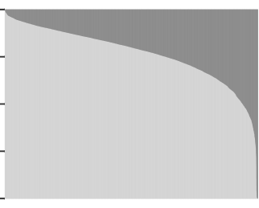

Ancestral Population  EUR  AFR

1.00

0.75

Admixture Proportion

0.50

0.25

0.00

1. JHS

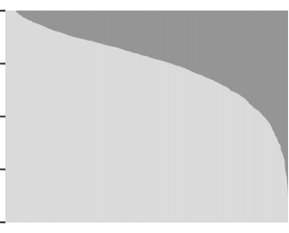

Ancestral Population  EUR  AFR

1.00

0.75

Admixture Proportion

0.50

0.25

0.00

1. COPDGene

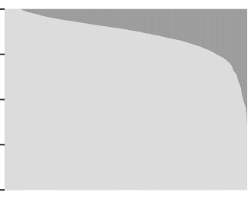

Ancestral Population  EUR  AFR

Figure 1: Barplots of estimated admixture proportions in (A) WHI SHARe, (B) TOPMed JHS, and (C) TOPMed COPDGene African Americans. Each individual is represented by a narrow vertical bar in the plot, and they are sorted by proportion of African ancestry.

proportion of African and European continental ancestry. Comparing model-based admix- ture proportions to principal components in WHI SHARe, JHS, and COPDGene confirms this hypothesis. In all three samples of African Americans, the first principal component is highly correlated with the inferred proportion of African ancestry, while later PCs show very little correlation with genome-wide continental ancestry (see Supplemental Figure S1). We observe similar patterns of correlation between PCs and inferred admixture proportions regardless of the type of LD filtering (or lack thereof) performed prior to running PCA. See Supplemental Information Section S1 for more discussion.

## Later PCs may capture local genomic features

As we see in Figure S1, in African American samples the first principal component seems to be capturing global ancestry, whereas later PCs are not. While it is possible that these higher-order principal components may be capturing sub-continental structure that is not captured by the model-based admixture proportions, we see in many cases that these later PCs are actually capturing local genomic features rather than genome-wide ancestry. This is evident upon inspection of *SNP loadings*, which represent the contribution of each variant to each principal component, or in investigating the correlation between principal component scores and the original genotypes.

Figure 2 presents the correlation between principal components and genotypes in JHS and COPDGene African Americans when PCs are generated without any prior LD-based pruning or filtering. We see that variants across the genome are contributing relatively equally to the first principal component, whereas the second, third, and fourth PCs are driven more- so by variants on a select number of chromosomes. In JHS, for example, the second PC is particularly highly correlated with variants on chromosomes 6 and 8, and less so with variants on 2, 3, and 11. We see similar patterns, although with peaks on different combinations of chromosomes, in COPDGene (Figure 2B) and WHI SHARe African Americans (Figure 3A). The peaks in these genotype-PC correlation plots indicate that those principal components are primarily capturing variation at a handful of positions along the genome rather than genome-wide global ancestry.

## Impact of LD pruning

Previous authors have suggested that this phenomenon of principal components capturing local genomic features arises due to high or otherwise unusual patterns of linkage disequilibrium among variants; as a result, they recommend that variants in high LD with one another be removed prior to running PCA. Following these recommendations, we compare the set of principal components based on all variants to PCs generated after first removing regions of the genome known to have high LD (Table 1), performing LD pruning, or both.

Figure 3 illustrates the impact of these pre-processing steps on the correlation between genotypes and PCs in WHI SHARe African Americans. Recall that the leftmost column of Figure 3 presents results for principal components that were generated without any prior LD-based filtering or pruning, and we see that PCs 2–4 are capturing local genomic features on a select number of chromosomes rather than genome-wide ancestry. When we exclude the previously-identified high LD regions reported in Table 1 before running PCA (Figure 3B), the pattern of *which* SNPs are driving PCs 2–4 changes, but the issue of PCs capturing local genomic features has not been resolved. However, after LD pruning with an *r*2 threshold of

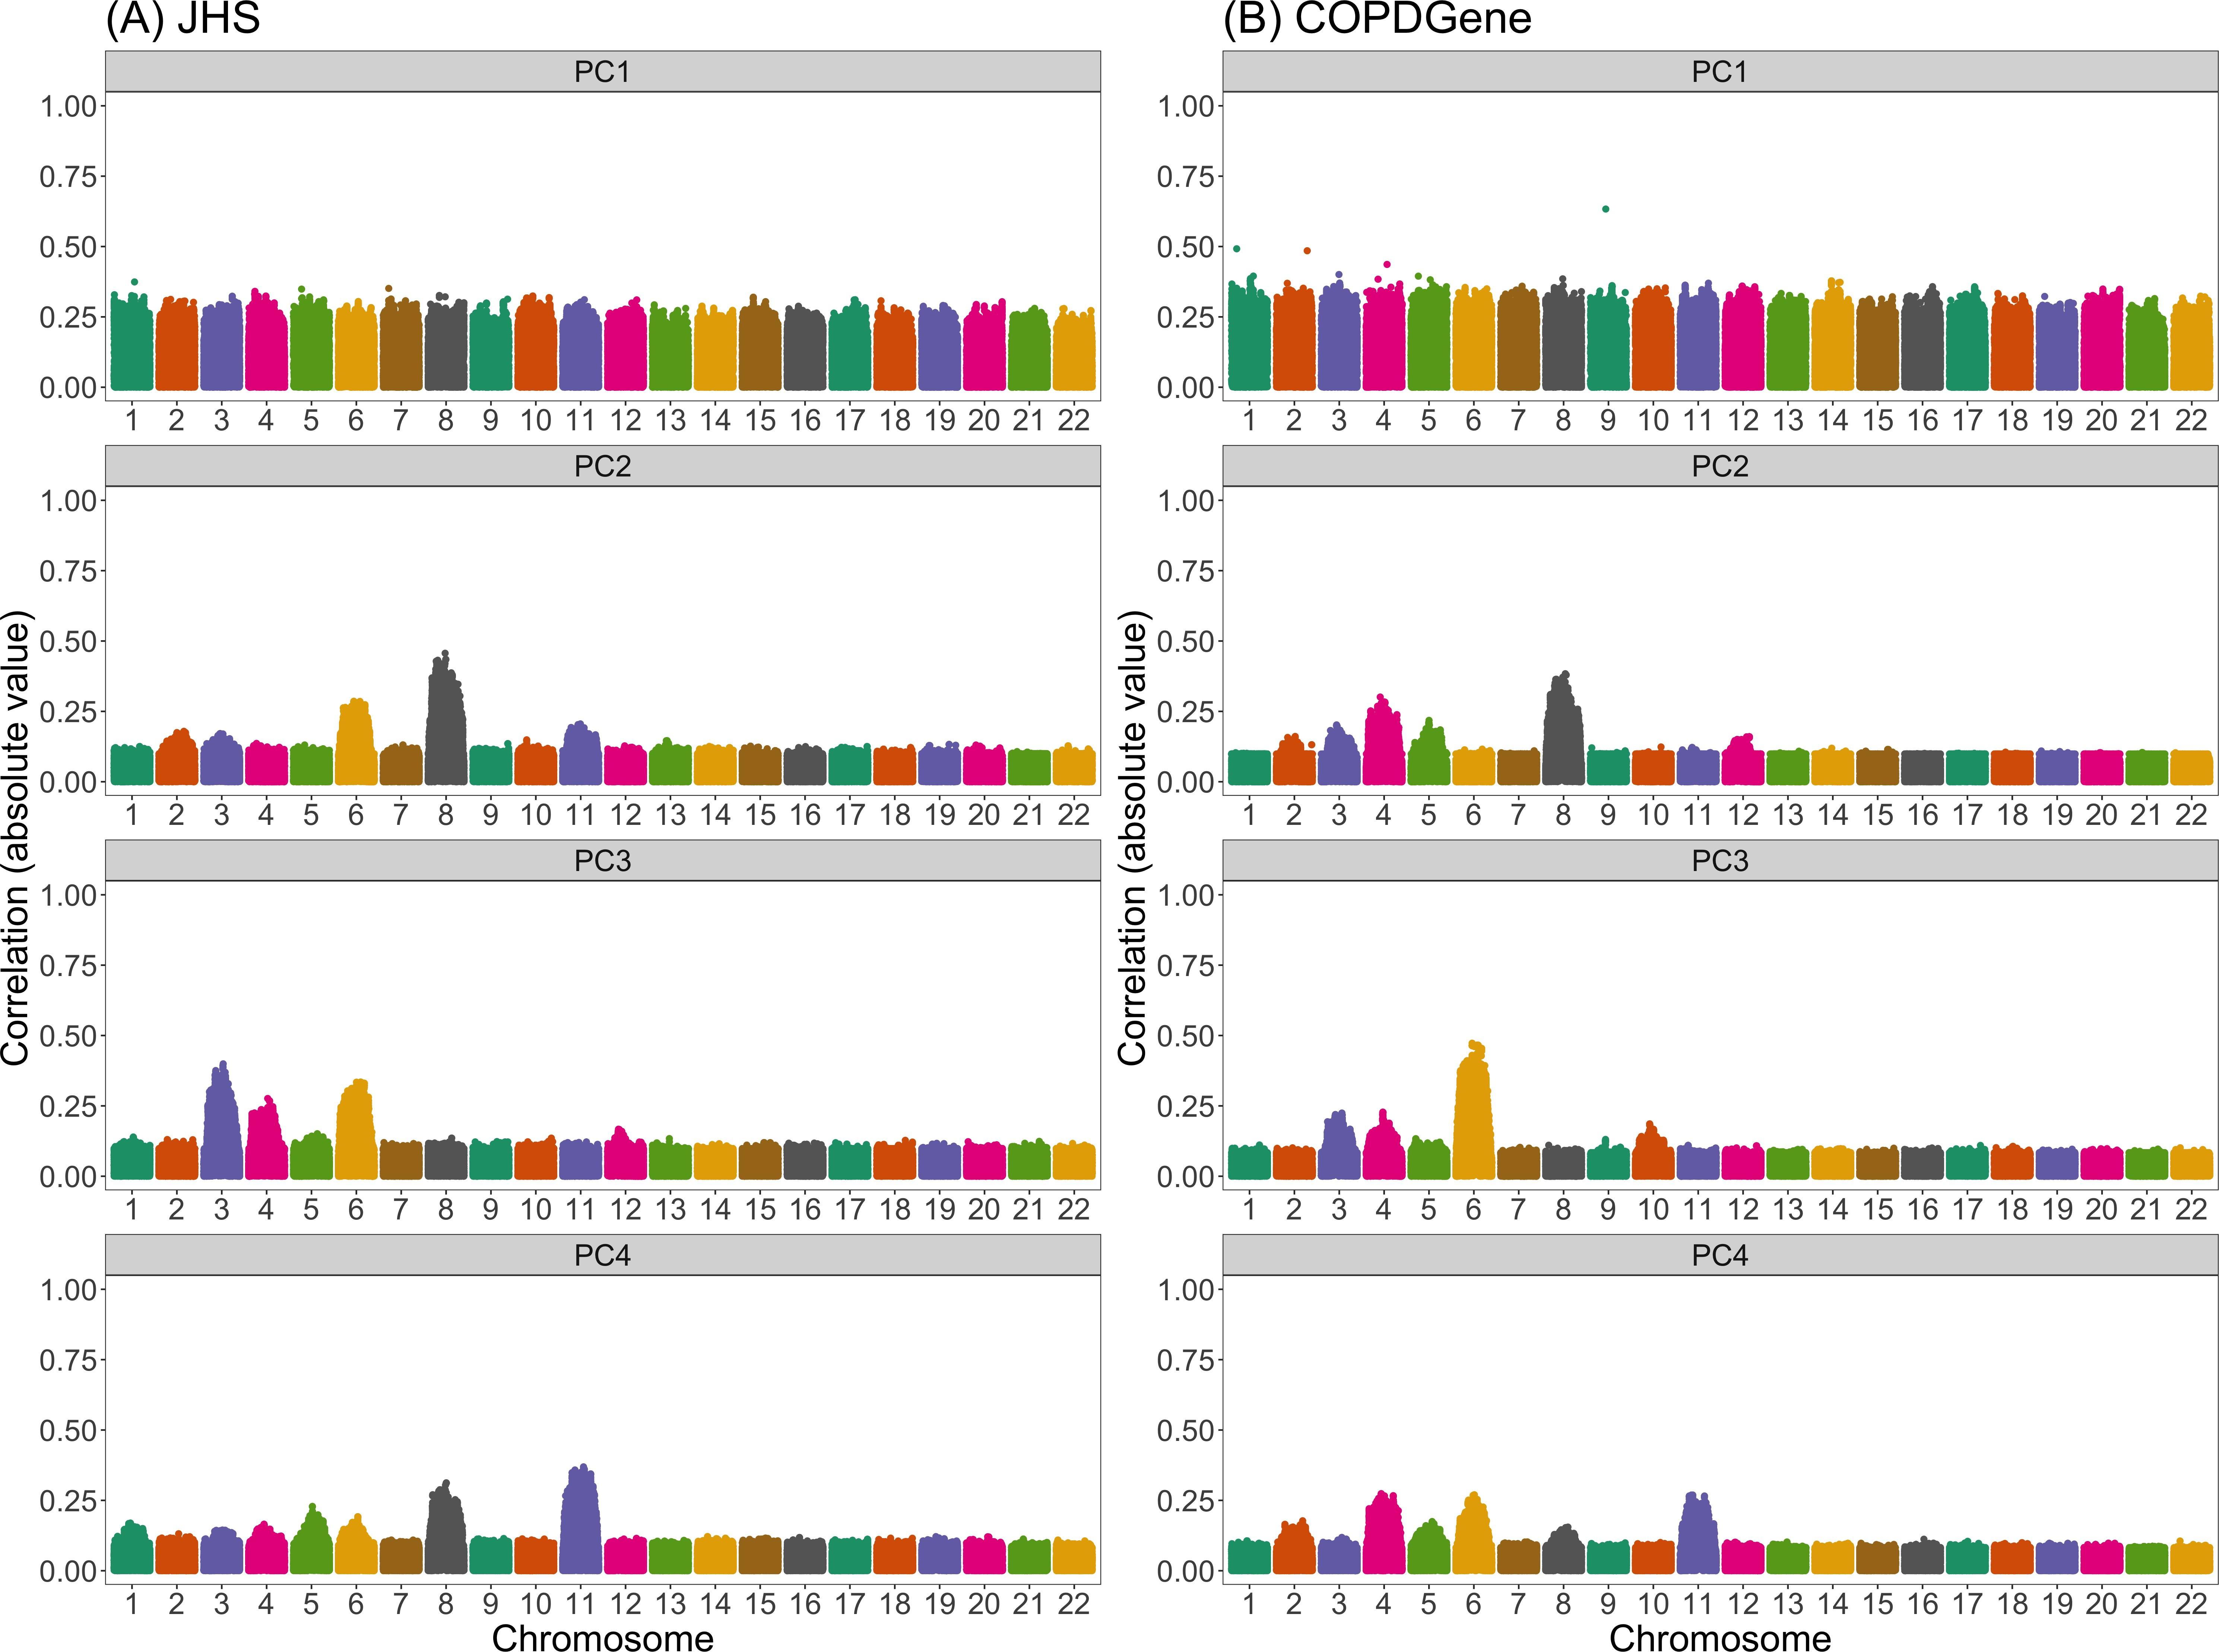

Figure 2: Correlation between naively generated PCs (i.e., PCs that were constructed without any prior LD-based filtering or exclusions) and genotypes in JHS and COPDGene African Americans. Each panel plots the absolute value of the correlation between principal components and genotypes (on the y-axis) versus the position along the genome (x-axis). Panels are organized vertically according to which PC is being investigated (1, 2, 3, 4) and horizontally according to the sample (A: JHS, B: COPDGene). Peaks in this plot indicate that a variant has a larger *loading*, i.e., a larger contribution to that principal component.

0.1 and a window size of 0.5 Mb (Figure 3C), we now see similar patterns with PCs 2–4 as we do with the first principal component: all variants are now contributing relatively equally to each PC. If we then also remove previously-identified high LD regions in addition to performing LD pruning (Figure 3D), the patterns of correlation between PCs and genotypes are indistinguishable from those with LD pruning alone. Similar patterns are observed in JHS and COPDGene.

Note that the thresholds for LD pruning that we use here (*r*2 *<* 0*.*1) are stricter than the default for many software programs and the threshold used in many studies of European populations (*r*2 *<* 0*.*2). If we use the larger, default *r*2 threshold, we see improvement for the second and third principal components, but the fourth continues to capture local genomic features (Supplemental Figure S3).

## Adjusting for PCs that capture local genomic features can induce spurious associations

We have demonstrated that, especially without strict LD pruning, principal components can capture local genomic features rather than global ancestry in admixed populations. However, it remains to be fully understood what the downstream implications would be of adjusting for these PCs in genome-wide association studies. We conducted a simulation study to investigate these implications further.

Figure 4 presents Manhattan plots from one replicate of our simulation study. In this setting, there is a single causal variant on chromosome 4, and we compare the results from genome-wide association studies in WHI SHARe African Americans using different ancestral heterogeneity adjustment approaches. As expected, we see extreme inflation, i.e., statistically significant associations on *every* chromosome, when we do not make any adjustment for ancestral heterogeneity (Panel A). Otherwise, when we infer and adjust for ancestral heterogeneity using either PCA or a model-based approach, we see a single peak in our Manhattan plot on chromosome 4—as hoped, given that is where the causal variant is located—with

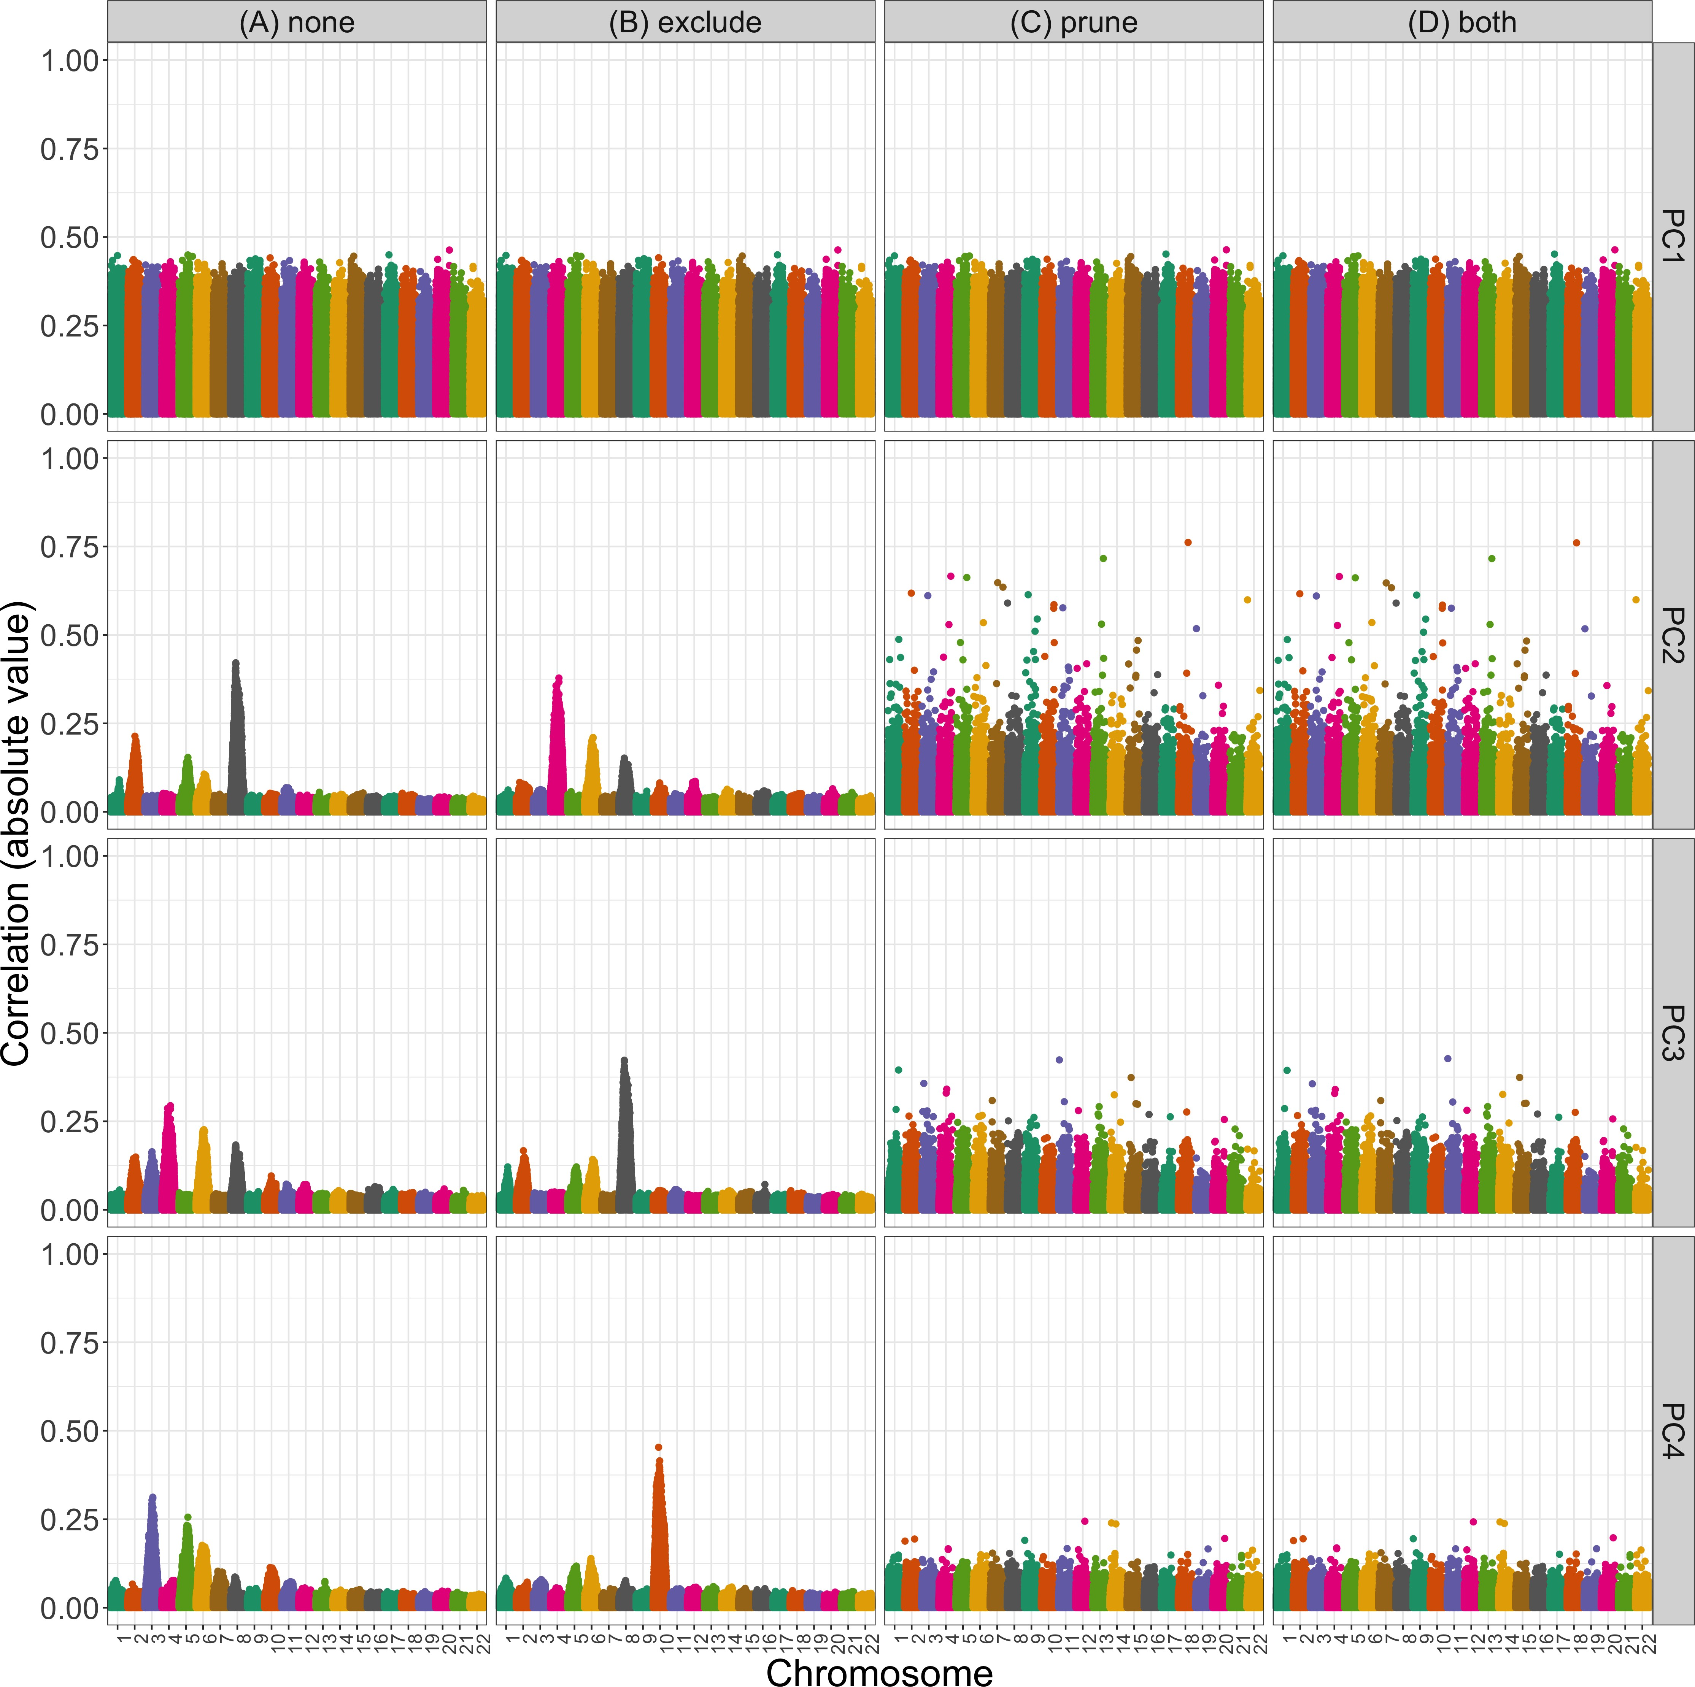

Figure 3: Correlation between PCs and genotypes in WHI SHARe African Americans with different choices of pre-processing. Each panel plots the absolute value of the correlation between principal components and genotypes (on the y-axis) versus the position along the genome (x-axis). Panels are organized vertically according to which PC is being investigated (1, 2, 3, 4) and horizontally according to the level of filtering that was applied prior to running PCA (*none*: all SNPs, *exclude*: after excluding regions in Table 1, *prune*: after LD pruning with an *r*2 threshold of 0.1 and window size of 0.5 Mb, and *both*: after both exclusions and LD pruning).

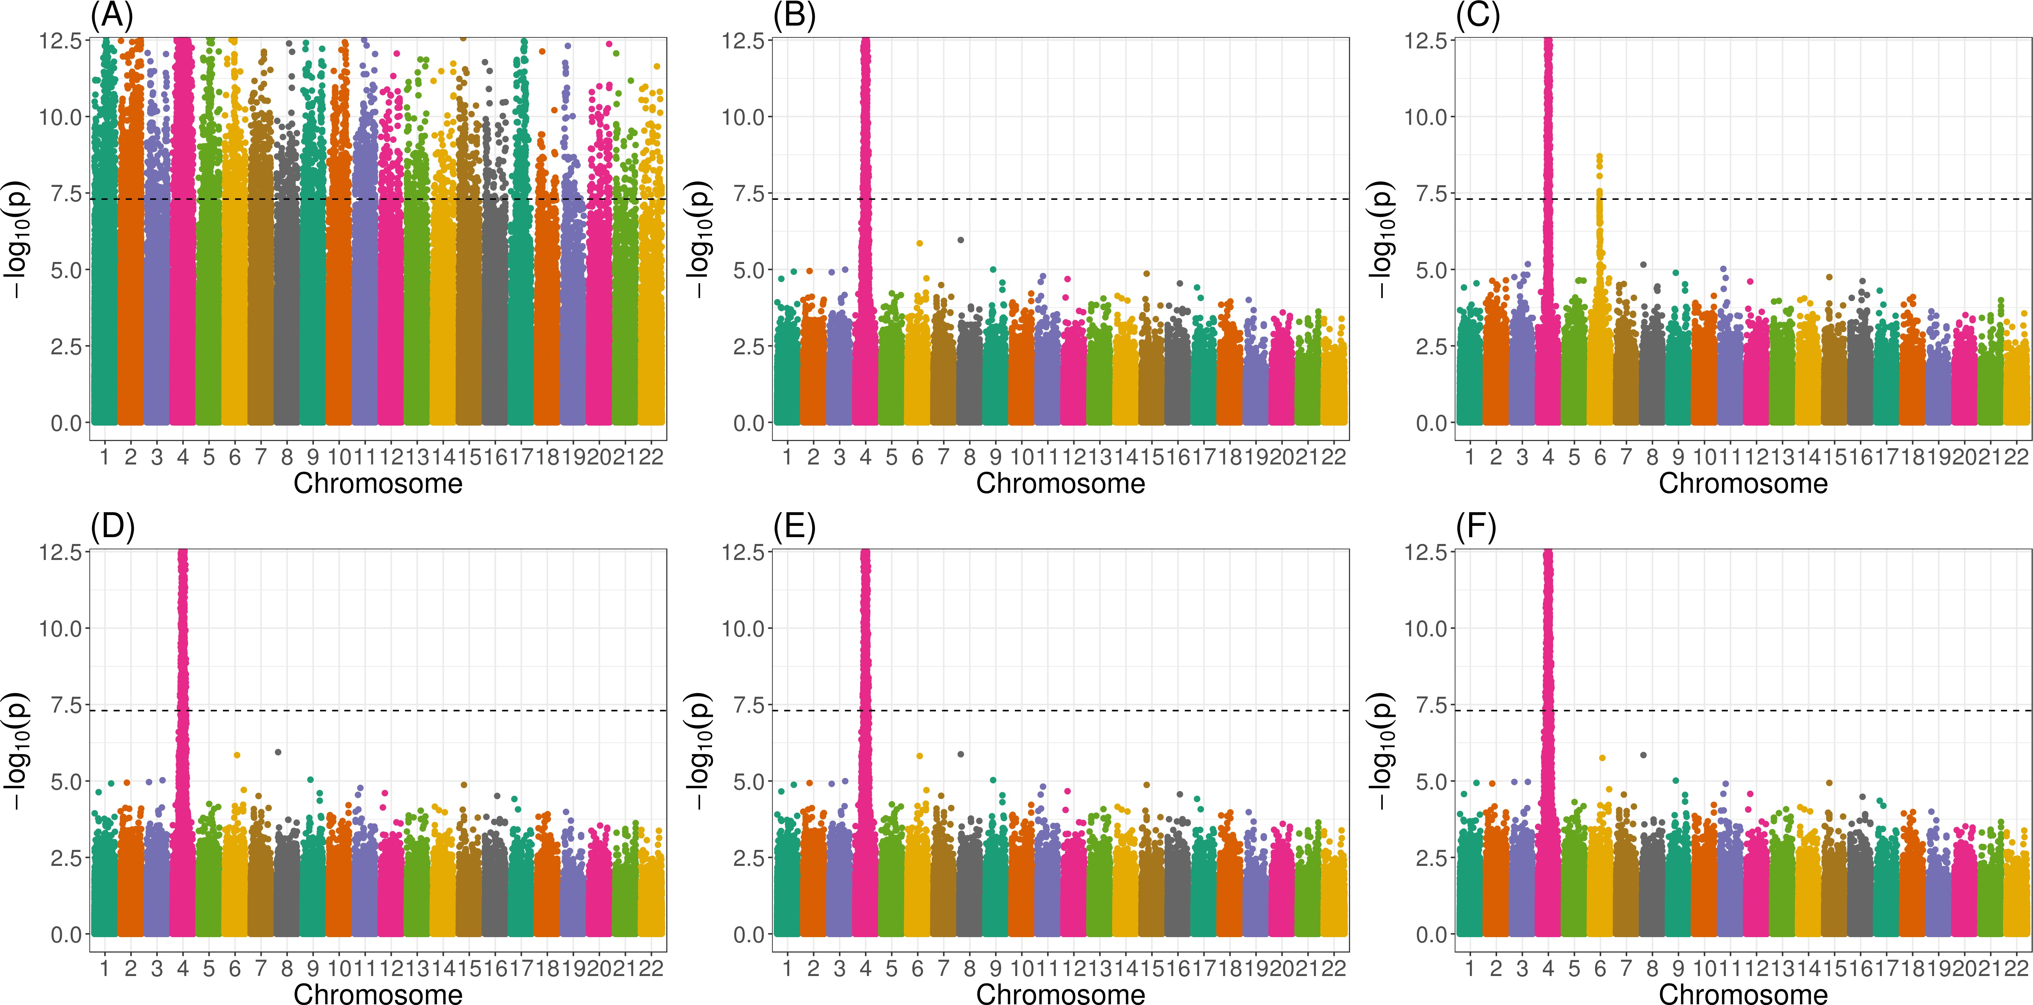

Figure 4: Manhattan plots from genome-wide association studies in WHI SHARe African Americans using different approaches to adjust for ancestral heterogeneity. In this example, the simulated trait depends only on the genotype at a single variant on chromosome 4. Panels present results using different adjustment approaches: (A) no adjustment; (B) one PC, with PCs calculated using all variants; (C) four PCs, with PCs calculated using all variants; (D) model-based admixture proportion estimates; (E) one PC, with PCs calculated after LD pruning (*r*2 *<* 0*.*1, window size = 0.5 Mb) and Table 1 exclusions; and (F) four PCs, with PCs calculated after LD pruning and exclusions. The horizontal dashed line in all panels represents the genome-wide significance threshold of 5 × 10*−*8.

one notable exception. When we adjust for the first four principal components (as has been done in previous GWAS in WHI SHARe32,65), where those PCs were generated without any prior LD-based pruning or filtering, then we see a spurious association on chromosome 6 (Panel C). However, this spurious association disappears if we only adjust for the first of these PCs (Panel B). Likewise, no spurious association arises if we adjust for model-based admixture proportions (Panel D) or if we use PCs that were generated after LD pruning and Table 1 exclusions (Panels E and F). Note that the causal variant, on chromosome 4, and the spurious signal, on chromosome 6, are both located in regions of the genome that are highly correlated with the PCs that were generated without any prior LD pruning (Figure 3).

These results are not unique to this simulation setting. In Figure 5, we see that adjusting

for PCs that capture local genomic features leads to higher numbers of spurious associations, on average, across all simulation settings. Comparing models that make some sort of ad- justment for ancestral heterogeneity, we observe the most spurious associations when GWAS models adjust for four principal components without any prior LD-based pruning or exclu- sions (represented by the orange solid line with circles in Figure 5). Excluding the high LD regions from Table 1 prior to running PCA (the orange solid line with triangles) reduces the number of observed spurious associations slightly, but not to the levels of the other ap- proaches. Given what we saw in Figure 3, this is not surprising: even with these exclusions, PCs 2–4 still capture local genomic features—unless those exclusions are also combined with strict LD pruning. On the other hand, when models include PCs that do not capture local genomic features, the rate of spurious associations drops. This includes models that adjust for just the first PC (the green lines in Figure 5) and models that include four PCs, but only after strict LD pruning (the orange dashed lines). Models that adjust for model-based admixture proportions (the purple solid line) perform nearly identically to models that ad- just for one PC. This, again, is not surprising, given the high correlation between admixture proportions and the first PC observed in this sample (Supplemental Figures S1 and S2).

## Factors that influence the rate of spurious associations

Our simulation results highlight various factors that influence when, and how many, spurious associations arise when adjusting for PCs that capture local genomic features. First, we note that there are very few spurious associations, regardless of the adjustment approach (or even lack thereof), when there are small differences in ancestral allele frequencies at the causal variant (Figure 5B). This is to be expected: in this scenario, the causal variant is not associated with global ancestry, so global ancestry is not a confounding variable and there is no need for adjustment. Considering other simulation settings in which the causal variant has a larger difference in ancestral allele frequencies (panels C, D, and E of Figure 5), so adjusting for ancestral heterogeneity is needed, the number of observed spurious associations

2.0

Average spurious associations

1.5

1.0

0.5

1. All simulation settings

2.0

Average spurious associations

1.5

1.0

0.5

1. Small diff. in ancestral allele freq.

Adjustment technique

1 PC

4 PCs

Model−based admixture prop. None

LD−based exclusions

None

Regions with high/extended LD

0.0

2.0

Average spurious associations

1.5

1.0

0.5

0.0

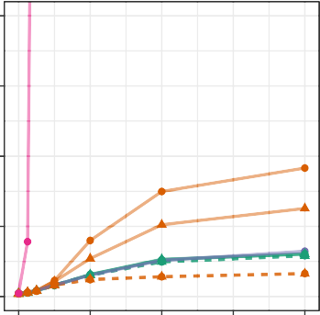0 2 4 6 8

Effect size of causal variant ()

1. Low loading

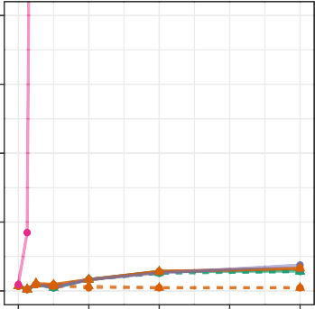

0 2 4 6 8

Effect size of causal variant ()

0.0

2.0

Average spurious associations

1.5

1.0

0.5

0.0

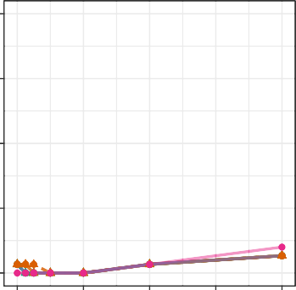0 2 4 6 8

Effect size of causal variant ()

1. High loading

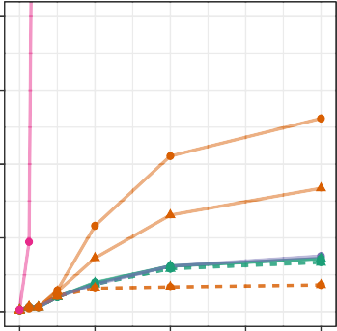

0 2 4 6 8

Effect size of causal variant ()

2.0

1.5

Average spurious associations

1.0

0.5

0.0

LD pruning

None

r^2 < 0.1, window = 0.5 Mb

1. Highest loading

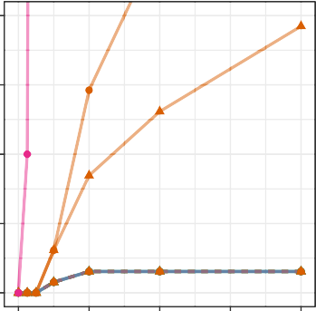

0 2 4 6 8

Effect size of causal variant ()

Figure 5: Comparison of the number of spurious associations in genome-wide association studies in WHI SHARe African Americans using different approaches to adjust for ancestral heterogeneity. Panel (A) displays the average number of spurious associations that were observed across all simulation settings. Remaining panels focus on the subset of simulation settings in which the causal variant has (B) a small difference in ancestral allele frequencies,

(C) low SNP loadings for each of the first four PCs, (D) a high SNP loading for at least one of the first four PCs, or (D) the highest SNP loading on its chromosome for one of the first four PCs. Within each panel, we compare the number of spurious associations when GWAS models adjust for model-based admixture proportions, 1 PC (with or without LD pruning and/or Table 1 exclusions), or 4 PCs (with or without LD pruning and/or Table 1 exclusions). Results shown here are for simulated traits with a single causal variant, with effect size (*β*) ranging from 0 to 8.

remains low for models that adjust for admixture proportions, a single principal component (regardless of pre-processing), or four PCs—if those PCs were generated after strict LD pruning. For the two models that adjust for PCs capturing local genomic features (i.e., the models that adjust for 4 PCs that were generated with or without Table 1 exclusions, but no LD pruning), however, we see a higher rate of spurious associations, particularly when the causal variant is highly correlated with one of those PCs. Notably, as the size of the causal variant's SNP loading increases from low (Figure 5C), to high (Figure 5D), to the highest on its chromosome (Figure 5E), we see an increasing number of spurious associations for these two approaches. This confirms the pattern we saw in Figure 4, where a spurious association arose when we adjusted for PCs that were highly correlated with variants in several regions across the genome, and both the causal variant and spurious signal were located in one of those regions. Finally, we note that these problems worsen as the effect size of the causal variant increases.

To better understand the patterns observed in our simulation study, we compare the expected effect size estimates from GWAS models in admixed populations with two ancestral populations using different techniques for adjusting for ancestral heterogeneity. As in our simulations, we assume that the trait depends on a single causal variant:

$$y_{i}∼_{iid}N\left(β_{1}g_{i1}+ β_{π}π_{i}, 1\right),$$

where *gi*1 represents the number of minor alleles carried by individual *i* at the causal variant, which we will refer to as *Variant 1*, and *πi* is the individual's admixture proportion. (Note that *βπ* = 0 in our simulation study, but we consider the more general setting here.) We can then derive the expected effect size estimate at that causal variant, as well as a second variant that is not associated with the trait and sits on a different chromosome than the causal variant. When we consider a GWAS model that adjusts for the true admixture proportions, the expected effect size estimates at the causal variant (Variant 1) and the unlinked neutral

variant (Variant 2) are

*E*[*β*ˆ1] = *β*1 *E*[*β*ˆ2] = 0*,*

(1)

where *β*1 is the true effect size of the causal variant and *β*2 = 0 is the true effect size of the neutral variant. In other words, models that perfectly adjust for ancestral heterogeneity will yield unbiased estimates of the effect size at the causal and unlinked neutral variants.

In comparison, GWAS models that do not make any adjustment for ancestral heterogeneity will yield effect size estimates of

$$E\left[{\hat{β}}_{1}\right]=β_{1}+ \frac{\left(p_{11}-p_{10}\right)V_{π}β_{π}}{p_{10}\left(1-p_{10}\right)+\left(p_{11}-p_{10}\right)\left(1-p_{11}-p_{10}\right)E_{π}+{\left(p_{11}-p_{10}\right)}^{2}{\left(V_{π}+E_{π}-E_{π}\right)}^{2}}$$

$$E\left[{\hat{β}}_{2}\right]=0+ \frac{\left(p_{21}-p_{20}\right)V_{π}[β_{π}+2 β_{1}(p_{11}-p_{10})]}{p_{20}\left(1-p_{20}\right)+\left(p_{21}-p_{20}\right)\left(1-p_{21}-p_{20}\right)E_{π}+{\left(p_{21}-p_{20}\right)}^{2}{\left(V_{π}+E_{π}-E_{π}\right)}^{2}} (2)$$

where *Eπ, Vπ* are the population mean and variance of the admixture proportions, *βπ* is the direct effect of admixture proportions on the trait, *p*11*, p*10 are the allele frequencies of the causal variant in the two ancestral populations, and *p*21*, p*20 are the ancestral allele

frequencies of the unlinked neutral variant. From these results, we see that the unadjusted model will yield a biased estimate of the effect size of the causal variant (*E*[*β*ˆ1] *β*1]) unless there is no ancestral heterogeneity (i.e., *Vπ* = 0), global ancestry does not have a direct effect on the trait (i.e., *βπ* = 0), or the causal variant does not have different allele frequencies in

the ancestral populations (i.e., *p*11 = *p*10). We see, also, that the model can yield a biased effect size at the unlinked neutral variant (*E*[*β*ˆ2] $≠$ 0) even if global ancestry does not have a direct effect on the trait, provided that both the causal variant and the variant being tested have allele frequencies that differ between the two ancestral populations (i.e., *p*11 *p*10 and *p*21 *p*20). These biased effect size estimates at neutral variants will translate into spurious associations as sample sizes increase, just as we saw in our simulations (Figures 4 and 5).

These results are summarized in Figure 6 and underscore the importance of adjusting for ancestral heterogeneity even when global ancestry does not have a direct effect on the trait.

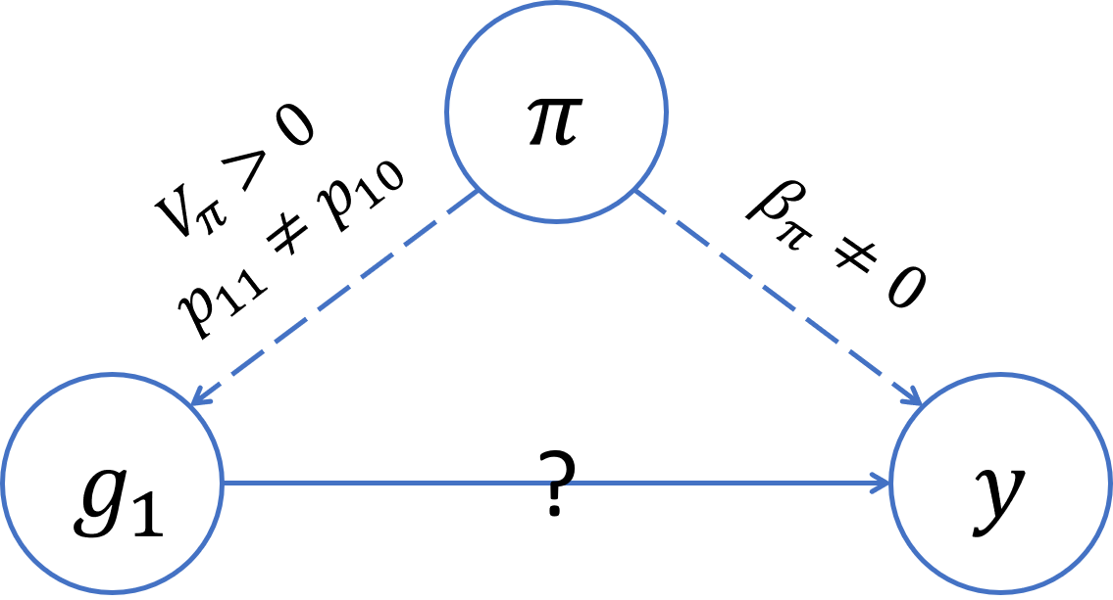 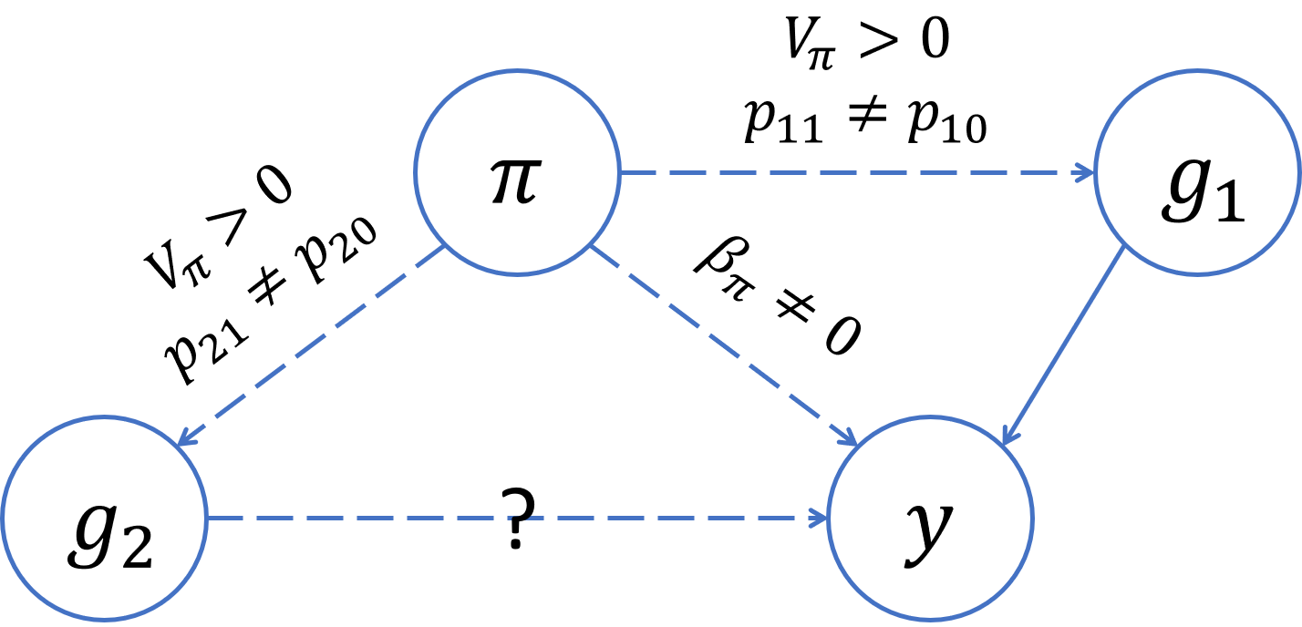

Figure 6: Directed acyclic graphs (DAGs) summarizing the conditions for confounding by global ancestry in GWAS. On the left, we see that global ancestry confounds the association at the causal variant (Variant 1) if there is ancestral heterogeneity in the population (*Vπ >* 0), the causal variant has different allele frequencies in the ancestral populations (*p*11 *p*10), and global ancestry has a direct effect on the trait (*βπ*  0). On the right, we see that global ancestry can confound the association at an unlinked neutral variant (Variant 2) even if global ancestry does not have a direct effect on the trait (*βπ* = 0), provided that there is ancestral heterogeneity (*Vπ >* 0) and both the causal variant and the variant being tested have different allele frequencies in the ancestral population (*p*11 *p*10*, p*21 *p*20).

To mimic the idea of adjusting for principal components that adjust for local genomic features, we also consider a scenario in which our GWAS model adjusts for two “principal components”. We assume that the first principal component captures global ancestry (i.e., **u**1 = ***π***) but the second principal component captures some feature other than global ancestry (i.e., **u**2 = **z** for some variable *z*). Then, we can show that the expected effect size estimates at the causal variant and an unlinked neutral variant will be

$$E\left[{\hat{β}}_{1}\right]=β_{1}$$

$$E\left[{\hat{β}}_{2}\right]=0+β_{1}\frac{-V_{π}E[Cov(g_{1},z|π)]E[Cov\left(g_{2}, z\right|π)]}{V_{z}\left(V_{π}V_{g_{2}}-C_{g_{2},π}^{2}\right)-V_{π}C_{g_{2},z}^{2}+C_{π, z}(2C_{g_{2}, π}C_{g_{2}, z}-V_{g_{2}}C_{π, z})} (3)$$

where *Va* = Var(*a*) and *Ca,b* = Cov(*a, b*). We see that this model adjusting for an extraneous principal component will yield an unbiased effect size estimate at the causal variant, but the same is not true for the unlinked neutral variant. In particular, the effect size estimate at this neutral variant will be biased away from zero when there is ancestral heterogeneity (i.e., *Vπ*  0) and the second principal component is correlated with both the causal variant and the variant being tested (i.e., Cov(*g*1*, z* | *π*) 0 and Cov(*g*2*, z* | *π*) 0)). In other

words, these results indicate that if a model adjusts for a PC that captures genotype at the causal variant as well as a second variant that is not associated with the trait, then spurious associations will arise at that second neutral variant in large enough samples. This is exactly what we observe in our simulations (Figure 4C, Figure 5D, Figure 5E). However, if the extra PC does not capture genotype at the causal variant, then spurious associations will not arise (Figure 4F, Figure 5C).

Proofs and simulations validating all of these analytic results are available in Sections S4 and S5 of the Supplemental Information.

# Discussion

We observe considerable variability in global ancestry proportions across all three of the admixed populations studied in this paper: the Women's Health Initiative SNP Health As- sociation Resource (WHI SHARe), Trans-Omics for Precision Medicine Jackson Heart Study (TOPMed JHS), and TOPMed Chronic Obstructive Pulmonary Disease Genetic Epidemiol- ogy Study (COPDGene) African Americans. It is widely understood that adjusting for this ancestral heterogeneity in genome-wide association studies is needed in order to control for potential confounding by global ancestry—and the spurious associations that can arise as a result. As we've shown above, this confounding can occur even when global ancestry does not have a direct effect on the trait itself, provided that there is a causal variant elsewhere in the genome that has different allele frequencies across the ancestral populations of interest. Although this fact has been recognized previously66, it is sometimes overlooked. Our theo- retical work (Equation 2) explicitly demonstrates the factors that impact the magnitude of the bias incurred by GWAS models that fail to adjust for global ancestry, and we hope that our results will serve as a reminder to researchers of the various ways in which global ancestry can confound genetic studies in admixed populations and the importance of ensuring that GWAS models appropriately adjust for ancestral heterogeneity.

A common approach for adjusting for ancestral heterogeneity in GWAS involves including global ancestry as a covariate in marginal regression models, with global ancestry estimated using either model-based approaches or principal component analysis. In WHI SHARe, TOPMed JHS, and TOPMed COPDGene African Americans, the first principal component is highly correlated with model-based estimates of the genome-wide proportion of African ancestry and models adjusting for either perform similarly. Later PCs, however, do not correlate with global ancestry and models that adjust for these PCs anyway—a common practice in the literature—can yield elevated rates of spurious associations, particularly when those PCs capture local genomic features rather than genome-wide ancestry. Prior work (e.g.,42,44) has shown that PCs can detect regions with high, extensive, or otherwise unusual patterns of linkage disequilibrium (Table 1), but the patterns observed in those studies— primarily involving individuals of European ancestry—differ from what we see here. These prior studies saw PCs that were driven by variants in a single high-LD region, just as we see in TOPMed COPDGene European Americans (Supplemental Figure S6). However, in all three of the admixed samples that we investigated, we see instead that PCs often capture *multiple* regions, across multiple chromosomes. This has important downstream implications.

Our simulations show that GWAS models adjusting for PCs that capture multiple local genomic features have elevated rates of spurious associations. This can be explained by the concept of *collider bias* (Figure 7). In particular, if a PC captures the genotype of multiple variants, and at least one of those variants is associated with the trait, then the PC becomes a *collider variable* when testing the association between the other variants and the trait. Adjusting for collider variables can induce a spurious association between variables that are otherwise unlinked67. This is precisely what we we see above. Our theoretical work (Equation 3) shows that GWAS models adjusting for an extraneous PC will yield biased estimates of variant effect sizes, with the magnitude of that bias increasing with the effect size of the causal variant, the strength of the correlation between the PC and the variants it captures, and the amount of ancestral heterogeneity within the population. When that bias

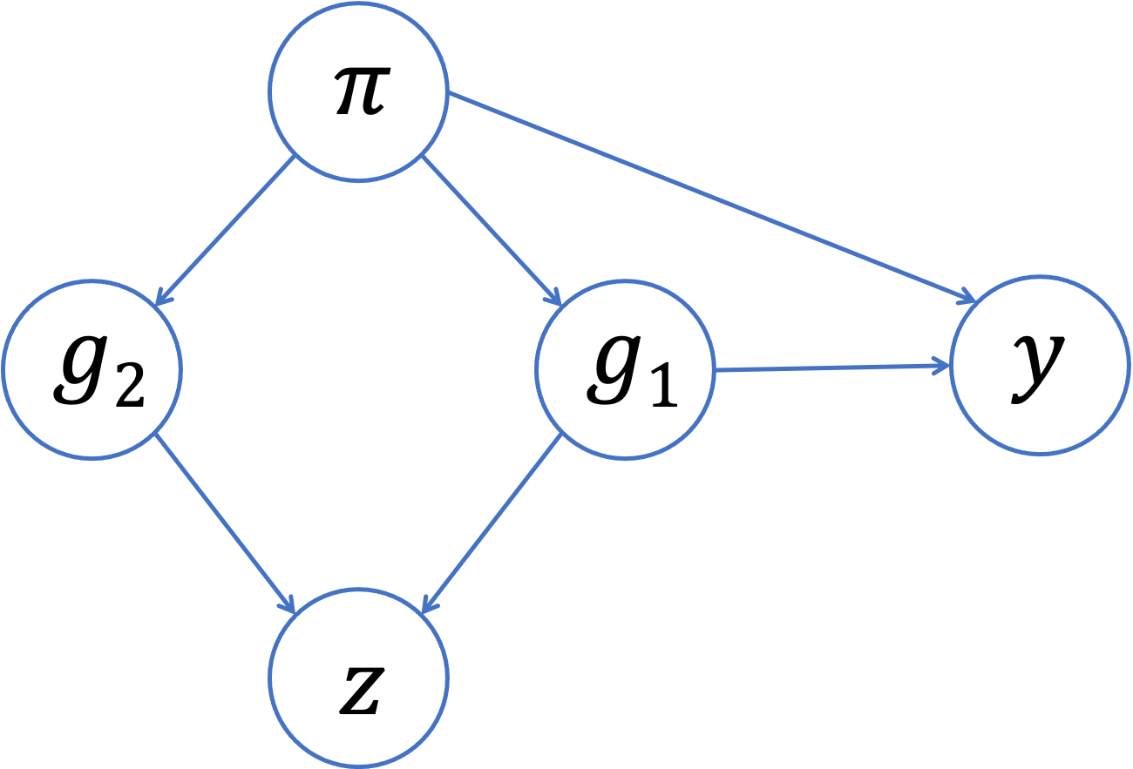

Figure 7: Collider bias in GWAS. Suppose that, instead of genome-wide global ancestry (*π*), a principal component (*z*) captures the genotype of two variants (*g*1*, g*2). If one of those variants (*g*1) is associated with the trait, then the PC will be a collider variable—rather than a confounding variable—when testing the association between the other variant (*g*2) and the trait. Adjusting for the PC can then induce a spurious association between the trait and the neutral variant as a result of collider bias.

is large enough, it could even lead to a spurious associations — as our simulations show. Given the similarities in terms of which regions of the genome tend to be captured by PCs across different admixed populations (see Figures 2 and 3, for example), it is possible that these spurious associations may even replicate across studies.

Increasing attention has been paid to the issue of collider bias in genetic association stud- ies in recent years68,69,70,71, but to our knowledge this is the first paper to fully demonstrate the concerns related to including extraneous principal components in GWAS models. In fact, the focus in the literature has typically been on demonstrating issues that can arise when adjusting for *too few* principal components7,18,72. One recent paper does show that adjust- ing for principal components can lead to replicating spurious associations in gene expression studies due to collider bias73. As a short aside, the authors also mention that collider bias could arise in GWAS, but they imply that the magnitude of this bias would be small— and thus not of practical concern—given that “causal SNPs have much lower leverage on genetic PCs” (i.e., the correlation between PCs and causal variants is small). Our findings support this conclusion that the magnitude of collider bias depends on the strength of the correlation between the PCs and the variants they capture. In contrast, however, we see that

this correlation between PCs and genetic variants can be non-trivial in admixed populations (without careful pre-processing prior to running PCA), implying that collider bias is of more concern in this setting than previous authors may have realized. We also see that the amount of bias depends on the variance of admixture proportions across a population (denoted *Vπ* in Equation 3), which could explain why prior work that has focused on more ancestrally homogenous populations may not have previously identified this issue. That said, it is important to raise the question of the magnitude of bias that could be expected in a “typical” genome-wide association study. The smaller the effect size of the causal variant, the smaller the number of spurious associations that we observed in our simulation study (Figure 5), and when studying complex traits/diseases we would expect the causal variant effect sizes to be fairly small. However, in these settings we would also expect that there are *multiple* causal variants—not just a single causal variant, as we assumed for the sake of simplicity in our simulations and theoretical work—and then these effects may be aggregated74. In any case, it is worth considering what steps can be taken to reduce or eliminate concerns about potential collider bias altogether.

In our analysis of genotype and sequence data from unrelated WHI SHARe, TOPMed JHS, and TOPMed COPDGene African Americans, we found that all but the first principal component were largely driven by small regions of the genome—and thus have the potential to be collider variables—unless careful pre-processing of genotype data was preformed prior to running PCA. As mentioned earlier, previous studies have found that PCs can capture small regions of the genome, and as a result have suggested that these regions be excluded (Table 1) and/or that LD pruning be performed prior to running PCA. However, the mo- tivation for this LD-based filtering has typically been framed in terms of the ability of the principal components to capture global ancestry, as well as the computational complexity of running PCA, rather than the downstream implications on association testing that we have highlighted here. Furthermore, we have found that excluding the regions listed in Table 1, without also performing LD pruning, does not actually seem to solve these issues in admixed

populations: we still see peaks in the PC-genotype correlation plots and models adjusting for these PCs continue to show elevated rates of spurious associations. A more tedious itera- tive approach of identifying and removing potentially problematic regions based on our own data also does not prevent PCs from capturing local genomic features within a reasonable number of iterations (Supplemental Figure S5). LD pruning, on the other hand, proves to be more successful, at least when looking at the first four principal components. However, our results highlight that a stricter threshold (e.g., *r*2 = 0.1) is needed for LD pruning in admixed populations than is often suggested in the literature (*r*2 = 0.2): see Supplemental Information Section S2 for a comparison. Given that linkage disequilibrium patterns differ between admixed populations and the European populations upon which much of this prior work was based, it is not surprising that different LD-based filtering techniques are required here.

Ultimately, our work demonstrates the challenges that can arise in appropriately adjust- ing for ancestral heterogeneity in genome-wide association studies admixed populations. For populations where we have a good idea of the number of ancestral populations of interest and relevant reference panel data is readily available, we suggest that GWAS models adjust for model-based estimates of global ancestry rather than principal components. However, if investigators feel strongly that PCA is needed to capture relevant levels of ancestral hetero- geneity, then careful consideration must be given to how many PCs should be included and what those PCs are capturing. In the African American samples studied here, for example, a single principal component was sufficient for controlling spurious associations induced by population structure and including additional PCs did not provide any further benefit. If further PCs are to be included, then careful pre-processing of data prior to running PCA, combined with thorough diagnostics (e.g., by calculating and plotting SNP loadings or the correlation between PCs and genotypes), is critical to ensure that models do not include principal components that could actually cause the very problem—spurious associations—that these techniques aim to solve.

# Supplemental Information

Supplemental Information includes 13 figures, as well as proofs and simulations validating the theoretical results presented in the main paper.

# Declaration of Interests

The authors declare no competing interests.

# Acknowledgments

K.E.G. was supported in part by the National Science Foundation Graduate Research Fel- lowship Program under grant no. DGE-1256082. Any opinions, findings, and conclusions or recommendations expressed in this material are those of the author(s) and do not necessarily reflect the views of the National Science Foundation.

The WHI program is funded by the National Heart, Lung, and Blood Institute, National Institutes of Health, U.S. Department of Health and Human Services through contracts HHSN268201600018C, HHSN268201600001C, HHSN268201600002C, HHSN268201600003C,

and HHSN268201600004C. The authors thank the WHI investigators and staff for their dedication, and the study participants for making the program possible. A listing of WHI investigators can be found at h[ttps://www.whi.org/do](http://www.whi.org/doc/WHIInvestigator-Long-List.pdf)c/WHIIn[vestigator-Long-List.pdf](http://www.whi.org/doc/WHIInvestigator-Long-List.pdf) Sharon will add TOPMed acknowledgements and grant information.

Please let me know if anyone would like me to add anything else.

# Data and Code Availability

WHI SHARe genotype data and TOPMed whole genome sequence data are available for analysis upon request and application. Visit study sites and dbGaP for more information.

All software packages used throughout this paper are freely available online:

* bcftools57 (quality control): <https://samtools.github.io/bcftools/>
* RFMix24 (local ancestry inference): <https://sites.google.com/site/rfmixlocalancestryinference/>
* ADMIXTURE23 (global ancestry inference): <https://dalexander.github.io/admixture/>
* PCRelate54 and PC-AiR26 (identifying unrelated individuals): <https://rdrr.io/bioc/GENESIS/>
* SNPRelate25 (LD pruning, PCA, and PCA-related diagnostics): <https://www.bioconductor.org/packages/release/bioc/html/SNPRelate.html>
* PLINK45 (GWAS): <https://zzz.bwh.harvard.edu/plink/>
* TOPMed Analysis Pipeline (identifying unrelated individuals, LD pruning, PCA, PCA- related diagnostics, and association studies in whole genome sequence data): [https://github.com/UW-GAC/analysis pipeline](https://github.com/UW-GAC/analysis_pipeline)
* R (analyzing and visualizing results): <https://cran.r-project.org/>

Other resources pertaining to this paper, including download-able lists of the high LD regions in Table 1 in various builds, can be found on the lead author's GitHub page:

* [https://github.com/kegrinde/PCA.](https://github.com/kegrinde/PCA)

The GitHub repository is currently private, but I'll make it public once the paper is submitted. If anyone would like to see the repository before I submit, let me know and I'll add you as a collaborator.

# References

1. Parra, E. J., Marcini, A., Akey, J., Martinson, J., Batzer, M. A., Cooper, R., Forrester, T., Allison, D. B., Deka, R., Ferrell, R. E. *et al.* (1998). Estimating african american admixture proportions by use of population-specific alleles. The American Journal of Human Genetics *63*, 1839–1851.
2. Tishkoff, S. A., Reed, F. A., Friedlaender, F. R., Ehret, C., Ranciaro, A., Froment, A., Hirbo, J. B., Awomoyi, A. A., Bodo, J.-M., Doumbo, O. *et al.* (2009). The genetic structure and history of africans and african americans. Science *324*, 1035–1044.
3. Bryc, K., Auton, A., Nelson, M. R., Oksenberg, J. R., Hauser, S. L., Williams, S., Froment, A., Bodo, J.-M., Wambebe, C., Tishkoff, S. A. *et al.* (2010). Genome-wide patterns of population structure and admixture in west africans and african americans. Proceedings of the National Academy of Sciences *107*, 786–791.
4. Bryc, K., Velez, C., Karafet, T., Moreno-Estrada, A., Reynolds, A., Auton, A., Ham- mer, M., Bustamante, C. D., and Ostrer, H. (2010). Genome-wide patterns of popu- lation structure and admixture among hispanic/latino populations. Proceedings of the National Academy of Sciences *107*, 8954–8961.
5. Conomos, M. P., Laurie, C. A., Stilp, A. M., Gogarten, S. M., McHugh, C. P., Nelson,

S. C., Sofer, T., Fern´andez-Rhodes, L., Justice, A. E., Graff, M. *et al.* (2016). Genetic diversity and association studies in us hispanic/latino populations: applications in the hispanic community health study/study of latinos. The American Journal of Human Genetics *98*, 165–184.

1. Devlin, B. and Roeder, K. (1999). Genomic control for association studies. Biometrics

*55*, 997–1004.

1. Price, A. L., Patterson, N. J., Plenge, R. M., Weinblatt, M. E., Shadick, N. A., and Reich, D. (2006). Principal components analysis corrects for stratification in genome- wide association studies. Nature Genetics *38*, 904–909.
2. Marchini, J., Cardon, L. R., Phillips, M. S., and Donnelly, P. (2004). The effects of human population structure on large genetic association studies. Nature Genetics *36*, 512–517.
3. Price, A. L., Zaitlen, N. A., Reich, D., and Patterson, N. (2010). New approaches to population stratification in genome-wide association studies. Nature Reviews Genetics *11*, 459–463.
4. Need, A. C. and Goldstein, D. B. (2009). Next generation disparities in human genomics: concerns and remedies. Trends in Genetics *25*, 489–494.
5. Bustamante, C. D., Francisco, M., and Burchard, E. G. (2011). Genomics for the world. Nature *475*, 163–165.
6. Popejoy, A. B. and Fullerton, S. M. (2016). Genomics is failing on diversity. Nature News *538*, 161.
7. Hindorff, L. A., Bonham, V. L., Brody, L. C., Ginoza, M. E., Hutter, C. M., Manolio,

T. A., and Green, E. D. (2018). Prioritizing diversity in human genomics research. Nature Reviews Genetics *19*, 175.

1. Manolio, T. A. (2019). Using the data we have: improving diversity in genomic research. The American Journal of Human Genetics *105*, 233–236.
2. Lander, E. S. and Schork, N. J. (1994). Genetic dissection of complex traits. Science

*265*, 2037–2048.

1. Spielman, R. S., McGinnis, R. E., and Ewens, W. J. (1993). Transmission test for

linkage disequilibrium: the insulin gene region and insulin-dependent diabetes mellitus (iddm). American journal of human genetics *52*, 506.

1. Yu, J., Pressoir, G., Briggs, W. H., Bi, I. V., Yamasaki, M., Doebley, J. F., McMullen,

M. D., Gaut, B. S., Nielsen, D. M., Holland, J. B. *et al.* (2006). A unified mixed-model method for association mapping that accounts for multiple levels of relatedness. Nature Genetics *38*, 203–208.

1. Kang, H. M., Sul, J. H., Service, S. K., Zaitlen, N. A., Kong, S.-y., Freimer, N. B., Sabatti, C., Eskin, E. *et al.* (2010). Variance component model to account for sample structure in genome-wide association studies. Nature Genetics *42*, 348–354.
2. Yang, J., Zaitlen, N. A., Goddard, M. E., Visscher, P. M., and Price, A. L. (2014). Advantages and pitfalls in the application of mixed-model association methods. Nature Genetics *46*, 100–106.
3. Pritchard, J. K., Stephens, M., Rosenberg, N. A., and Donnelly, P. (2000). Association mapping in structured populations. The American Journal of Human Genetics *67*, 170–181.
4. Tang, H., Peng, J., Wang, P., and Risch, N. J. (2005). Estimation of individual admix- ture: analytical and study design considerations. Genetic Epidemiology *28*, 289–301.
5. Falush, D., Stephens, M., and Pritchard, J. K. (2003). Inference of population structure using multilocus genotype data: linked loci and correlated allele frequencies. Genetics *164*, 1567–1587.
6. Alexander, D. H., Novembre, J., and Lange, K. (2009). Fast model-based estimation of ancestry in unrelated individuals. Genome Research *19*, 1655–1664.
7. Maples, B. K., Gravel, S., Kenny, E. E., and Bustamante, C. D. (2013). Rfmix: a

discriminative modeling approach for rapid and robust local-ancestry inference. The American Journal of Human Genetics *93*, 278–288.

1. Zheng, X., Levine, D., Shen, J., Gogarten, S. M., Laurie, C., and Weir, B. S. (2012). A high-performance computing toolset for relatedness and principal component analysis of snp data. Bioinformatics *28*, 3326–3328.
2. Conomos, M. P., Miller, M. B., and Thornton, T. A. (2015). Robust inference of pop- ulation structure for ancestry prediction and correction of stratification in the presence of relatedness. Genetic epidemiology *39*, 276–293.
3. Novembre, J., Johnson, T., Bryc, K., Kutalik, Z., Boyko, A. R., Auton, A., Indap, A., King, K. S., Bergmann, S., Nelson, M. R. *et al.* (2008). Genes mirror geography within europe. Nature *456*, 98–101.
4. Patterson, N., Price, A. L., and Reich, D. (2006). Population structure and eigenanal- ysis. PLoS Genet *2*, e190.
5. McVean, G. (2009). A genealogical interpretation of principal components analysis. PLoS Genet *5*, e1000686.
6. Reed, E., Nunez, S., Kulp, D., Qian, J., Reilly, M. P., and Foulkes, A. S. (2015). A guide to genome-wide association analysis and post-analytic interrogation. Statistics in Medicine *34*, 3769–3792.
7. Raska, P., Iversen, E., Chen, A., Chen, Z., Fridley, B. L., Permuth-Wey, J., Tsai, Y.-Y., Vierkant, R. A., Goode, E. L., Risch, H. *et al.* (2012). European american stratification in ovarian cancer case control data: the utility of genome-wide data for inferring ancestry. Plos one *7*, e35235.
8. Reiner, A. P., Beleza, S., Franceschini, N., Auer, P. L., Robinson, J. G., Kooperberg, C., Peters, U., and Tang, H. (2012). Genome-wide association and population genetic

analysis of c-reactive protein in african american and hispanic american women. The American Journal of Human Genetics *91*, 502–512.

1. Daya, M., Rafaels, N., Brunetti, T. M., Chavan, S., Levin, A. M., Shetty, A., Gignoux,

C. R., Boorgula, M. P., Wojcik, G., Campbell, M. *et al.* (2019). Association study in african-admixed populations across the americas recapitulates asthma risk loci in non-african populations. Nature Communications *10*, 1–13.

1. Abegaz, F., Chaichoompu, K., G´enin, E., Fardo, D. W., K¨onig, I. R., Mahachie John,

J. M., and Van Steen, K. (2019). Principals about principal components in statistical genetics. Briefings in Bioinformatics *20*, 2200–2216.

1. Mathieson, I. and McVean, G. (2012). Differential confounding of rare and common variants in spatially structured populations. Nature Genetics *44*, 243–246.
2. Liu, N., Zhao, H., Patki, A., Limdi, N. A., and Allison, D. B. (2011). Controlling population structure in human genetic association studies with samples of unrelated individuals. Statistics and its interface *4*, 317.
3. Abdellaoui, A., Hottenga, J.-J., De Knijff, P., Nivard, M. G., Xiao, X., Scheet, P., Brooks, A., Ehli, E. A., Hu, Y., Davies, G. E. *et al.* (2013). Population structure, migration, and diversifying selection in the netherlands. European Journal of Human Genetics *21*, 1277–1285.
4. Weale, M. E. (2010). Quality control for genome-wide association studies. Genetic Variation , 341–372.
5. Consortium, W. T. C. C. *et al.* (2007). Genome-wide association study of 14,000 cases of seven common diseases and 3,000 shared controls. Nature *447*, 661.
6. Tian, C., Plenge, R. M., Ransom, M., Lee, A., Villoslada, P., Selmi, C., Klareskog,

L., Pulver, A. E., Qi, L., Gregersen, P. K. *et al.* (2008). Analysis and application of european genetic substructure using 300 k snp information. PLoS Genet *4*, e4.

1. Price, A. L., Weale, M. E., Patterson, N., Myers, S. R., Need, A. C., Shianna, K. V., Ge, D., Rotter, J. I., Torres, E., Taylor, K. D. *et al.* (2008). Long-range ld can confound genome scans in admixed populations. The American Journal of Human Genetics *83*, 132–135.
2. Zou, F., Lee, S., Knowles, M. R., and Wright, F. A. (2010). Quantification of population structure using correlated snps by shrinkage principal components. Human Heredity *70*, 9–22.
3. Laurie, C. C., Doheny, K. F., Mirel, D. B., Pugh, E. W., Bierut, L. J., Bhangale, T., Boehm, F., Caporaso, N. E., Cornelis, M. C., Edenberg, H. J. *et al.* (2010). Quality control and quality assurance in genotypic data for genome-wide association studies. Genetic Epidemiology *34*, 591–602.
4. Priv´e, F., Luu, K., Blum, M. G., McGrath, J. J., and Vilhj´almsson, B. J. (2020). Effi- cient toolkit implementing best practices for principal component analysis of population genetic data. Bioinformatics *36*, 4449–4457.
5. Purcell, S., Neale, B., Todd-Brown, K., Thomas, L., Ferreira, M. A., Bender, D., Maller, J., Sklar, P., De Bakker, P. I., Daly, M. J. *et al.* (2007). Plink: a tool set for whole- genome association and population-based linkage analyses. The American Journal of Human Genetics *81*, 559–575.
6. Fellay, J., Shianna, K. V., Ge, D., Colombo, S., Ledergerber, B., Weale, M., Zhang, K., Gumbs, C., Castagna, A., Cossarizza, A. *et al.* (2007). A whole-genome association study of major determinants for host control of hiv-1. Science *317*, 944–947.
7. Yu, K., Wang, Z., Li, Q., Wacholder, S., Hunter, D. J., Hoover, R. N., Chanock, S.,

and Thomas, G. (2008). Population substructure and control selection in genome-wide association studies. PloS one *3*, e2551.

1. Nelson, M. R., Bryc, K., King, K. S., Indap, A., Boyko, A. R., Novembre, J., Briley,

L. P., Maruyama, Y., Waterworth, D. M., Waeber, G. *et al.* (2008). The population ref- erence sample, popres: a resource for population, disease, and pharmacological genetics research. The American Journal of Human Genetics *83*, 347–358.

1. Anderson, C. A., Pettersson, F. H., Clarke, G. M., Cardon, L. R., Morris, A. P., and Zondervan, K. T. (2010). Data quality control in genetic case-control association studies. Nature Protocols *5*, 1564–1573.
2. Zhang, Y., Guan, W., and Pan, W. (2013). Adjustment for population stratification via principal components in association analysis of rare variants. Genetic epidemiology *37*, 99–109.
3. Galinsky, K. J., Bhatia, G., Loh, P.-R., Georgiev, S., Mukherjee, S., Patterson, N. J., and Price, A. L. (2016). Fast principal-component analysis reveals convergent evolution of adh1b in europe and east asia. The American Journal of Human Genetics *98*, 456–472.
4. Priv´e, F., Aschard, H., Ziyatdinov, A., and Blum, M. G. (2018). Efficient analysis of large-scale genome-wide data with two r packages: bigstatsr and bigsnpr. Bioinformatics *34*, 2781–2787.
5. Hays, J., Hunt, J. R., Hubbell, F. A., Anderson, G. L., Limacher, M., Allen, C., and Rossouw, J. E. (2003). The Women's Health Initiative recruitment methods and results. Annals of Epidemiology *13*, S18–S77.
6. Conomos, M. P., Reiner, A. P., Weir, B. S., and Thornton, T. A. (2016). Model-free estimation of recent genetic relatedness. The American Journal of Human Genetics *98*, 127–148.
7. Jun, G., Wing, M. K., Abecasis, G. R., and Kang, H. M. (2015). An efficient and scalable analysis framework for variant extraction and refinement from population-scale dna sequence data. Genome Research *25*, 918–925.
8. Taliun, D., Harris, D. N., Kessler, M. D., Carlson, J., Szpiech, Z. A., Torres, R., Taliun,

S. A. G., Corvelo, A., Gogarten, S. M., Kang, H. M. *et al.* (2021). Sequencing of 53,831 diverse genomes from the nhlbi topmed program. Nature *590*, 290–299.

1. Danecek, P., Bonfield, J. K., Liddle, J., Marshall, J., Ohan, V., Pollard, M. O., Whitwham, A., Keane, T., McCarthy, S. A., Davies, R. M. *et al.* (2021). Twelve years of samtools and bcftools. Gigascience *10*, giab008.
2. Consortium, I. H. . *et al.* (2010). Integrating common and rare genetic variation in diverse human populations. Nature *467*, 52.
3. Grinde, K. E., Brown, L. A., Reiner, A. P., Thornton, T. A., and Browning, S. R. (2019). Genome-wide significance thresholds for admixture mapping studies. The American Journal of Human Genetics *104*, 454–465.
4. Parker, M. M., Foreman, M. G., Abel, H. J., Mathias, R. A., Hetmanski, J. B., Crapo,

J. D., Silverman, E. K., Beaty, T. H., and Investigators, C. (2014). Admixture mapping identifies a quantitative trait locus associated with fev1/fvc in the copdgene study. Genetic Epidemiology *38*, 652–659.

1. University of Washington Genetic Analysis Center. (2022). TOPMed Analysis Pipeline.

<https://github.com/UW-GAC/analysis_pipeline>.

1. Kirk, J. L. (2016). *Statistical methods for inferring population structure with human genome squence data*. PhD thesis, University of Washington.
2. Pe'er, I., Yelensky, R., Altshuler, D., and Daly, M. J. (2008). Estimation of the mul-

tiple testing burden for genomewide association studies of nearly all common variants. Genetic Epidemiology *32*, 381–385.

1. Jannot, A.-S., Ehret, G., and Perneger, T. (2015). P¡ 5× 10- 8 has emerged as a stan- dard of statistical significance for genome-wide association studies. Journal of Clinical Epidemiology *68*, 460–465.
2. Carty, C. L., Johnson, N. A., Hutter, C. M., Reiner, A. P., Peters, U., Tang, H., and Kooperberg, C. (2012). Genome-wide association study of body height in African Americans: The Women's Health Initiative SNP Health Association Resource (SHARe). Human Molecular Genetics *21*, 711–720.
3. Wacholder, S., Rothman, N., and Caporaso, N. (2002). Counterpoint: bias from popu- lation stratification is not a major threat to the validity of conclusions from epidemio- logical studies of common polymorphisms and cancer. Cancer Epidemiology Biomarkers & Prevention *11*, 513–520.
4. Elwert, F. and Winship, C. (2014). Endogenous selection bias: The problem of condi- tioning on a collider variable. Annual Review of Sociology *40*, 31.
5. Aschard, H., Vilhj´almsson, B. J., Joshi, A. D., Price, A. L., and Kraft, P. (2015). Adjusting for heritable covariates can bias effect estimates in genome-wide association studies. The American Journal of Human Genetics *96*, 329–339.
6. Day, F. R., Loh, P.-R., Scott, R. A., Ong, K. K., and Perry, J. R. (2016). A robust example of collider bias in a genetic association study. The American Journal of Human Genetics *98*, 392–393.
7. Cai, S., Hartley, A., Mahmoud, O., Tilling, K., and Dudbridge, F. (2022). Adjusting for collider bias in genetic association studies using instrumental variable methods. Genetic Epidemiology .
8. Hemani, G., Tilling, K. M., and Smith, G. D. (2022). Collider bias from selecting disease samples distorts causal inferences. Genetic Epidemiology *46*, 213–215.
9. Yao, Y. and Ochoa, A. (2022). Limitations of principal components in quantitative genetic association models for human studies. bioRxiv .
10. Dahl, A., Guillemot, V., Mefford, J., Aschard, H., and Zaitlen, N. (2019). Adjusting for principal components of molecular phenotypes induces replicating false positives. Genetics *211*, 1179–1189.
11. Di, Y., Mi, G., Sun, L., Dong, R., Zhu, H., and Peng, L. (2011). Power of association tests in the presence of multiple causal variants. In BMC Proceedings volume 5 pages 1–5, Springer.